Generic Connector Framework
Initiation Document
February 11, 2008

This document captures the history, need and a few top level specs for a generic connector framework.

Why:

Historically, we have been writing connectors to synchronize similar artifacts between two systems. But each of these connectors are from-scratch implementations – which meant more development and maintainance time and money, and also allow for mistakes to be repeated time and again.

With the advent of tools that permit enterprise wide data communication, it is easier today to read/write components for the required systems, and a connector can be written between any two systems with only the data transformation that needs to be redone everytime two new systems have to be connected.

Current State of the Connector

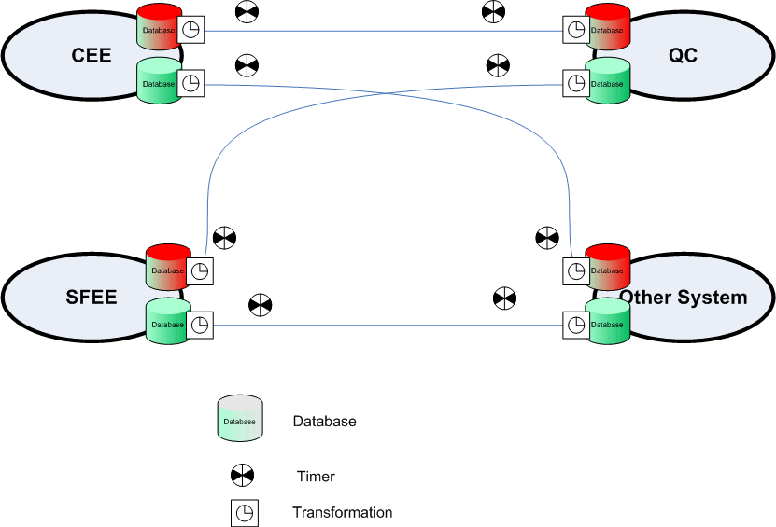

Proposed Generic connector with Core and plug-in architecture

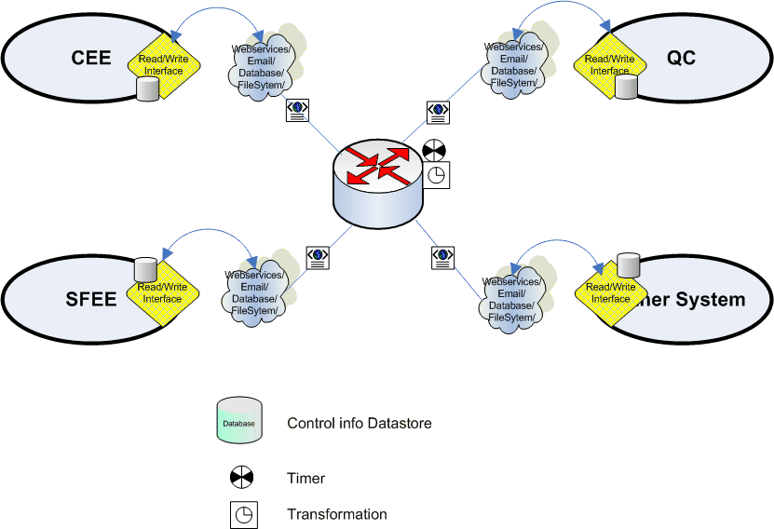

Overall system architecture:

The read/write connectors must be written for every system. In addition the generic connector core should contain a transformation xslt which should be provided for each system pair.

The read connector should take care of reading the system periodically, extracting and sending the records to the generic connector core. The read connector for every system should also take care of filtering out unnecessary records (like a record that was just added by the corresponding write connector into the system).

The generic connector core should handle transformations – like field names, values etc., from one system to another.

The write connector should take the records provided by the core connector, apply the corresponding system’s rules (for example, log error on missing mandatory fields) – and write the data into the system.

Data types:

The read/write connectors should be able to handle the following data types:

- String
- Date (with timezones)
- Number
- List
- User list
- Memo (html text)
- Comment (append to existing text)

In addition we need to also provide for attachment read/process/writing.

Logging:

There should be logs that should log information on errors and provide all possible information on the error.

Mails should be sent out to each project administrator with the error logs.

Internationalization Issues:
The connector should support multiple locales and timezones. I imagine this would work like this.
Locales: The read connector will convert any local encoding into UTF-8 (because the data travels in xml format – is there anyway we can use the native locale strings in xml without breaking it?), and hence any artifact record traveling within the Generic Connector framework will be in UTF-8 (any, except the source->Read connector part).
The write connector will convert the UTF-8 text to the local encoding in which the system exists.

Timezones: Any time field in any artifact record that travels within the GC framework shall have the timezone information present. When the write connector is ready to write this info into the system, it must refer to a configuration parameter that would describe if the date should be converted from the source timezone to the native timezone (Not all systems might want the time to look different on the two ends)

Configuration and xslt:

The xslts that are used by the Generic Connector core are not end-user friendly. So, we would have to write a xslt/code-based transformation tool that, given the input xslt and the user configuration, generates the xslt that could be used by the Generic Connector core.

UI Configuration:

Furthermore, in the future, we should look at developing a UI configuration tool that helps the user configure the field mapping and the connections.

Automated Tests:

Testing is always a major effort as experienced by us in our earlier connectors. We should aim at simplifying this by writing automated test cases that can be run for a few hours and verified.

Since the generic connector is a combination of individual system plugins (interfaces) and the Generic Connector Core, it would be time-consuming and complex to test for all possible combinations of plugins for any given plugin. (But we might decide to test certain combinations explicitly)

One good way to test each system is to define the boundaries till which the connector could fail for that system.

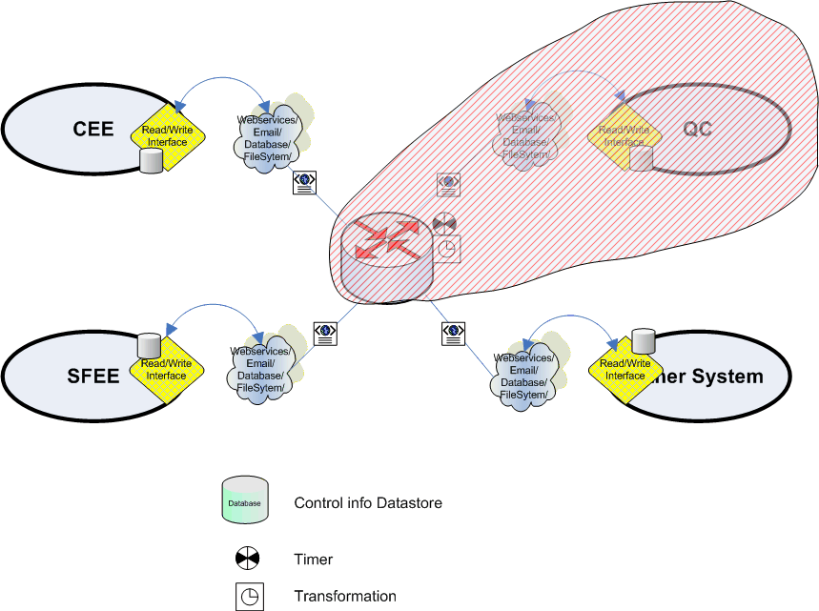

To make this possible, we would have to write a stub using open adaptor’s standard components, to read data from files and pass them to the Generic Connector Core.

Similarly, we have to write a stub to read from the Generic Connector code and compare it against pre-generated expected outputs.

However, the QA team would have to qualify certain pairs of connectors before release to the customers. (How to automate this testing?)

